Samuel Harkness
PHYS 221
Angular Motion

This lab had two learning goals. First, we discovered the meanings of the rotational variables Theta (θ), Omega (ω), and Alpha (α) and how they are related. We then explored the relationships of these rotational variables to their linear counterparts, x, v, and a. To conduct this experiment we were provided a rotary motion sensor with an aluminum disk mounted on a stand as shown below.
We were tasked with obtaining a set of graphs for each of the following circumstances:
- a period of time showing constant angular speed,
- a period of time showing increasing angular speed and constant angular acceleration,
- a period of time showing decreasing angular speed and constant angular acceleration.
To obtain i), we attached an equal mass to both ends of a string that ran around the aluminum disk. We then gave the system a slight impulse, because with an initial push the system would remain in equilibrium.
To obtain ii), we attached a mass to one end of the string, and then wrapped the other end around the disk multiple times and suspended the mass so that it was held near the disk. When the mass was released, the disk accelerated at the rotational equivalent to linear gravity.
To obtain iii), we repeated ii), except we did not suspend the mass. Instead, we then spun the disk around and lifted the mass off of the table, and then let it fall back down.
Note that a positive ω signifies that the disk is rotating counter-clockwise, and negative signifies that the disk is rotating clockwise.
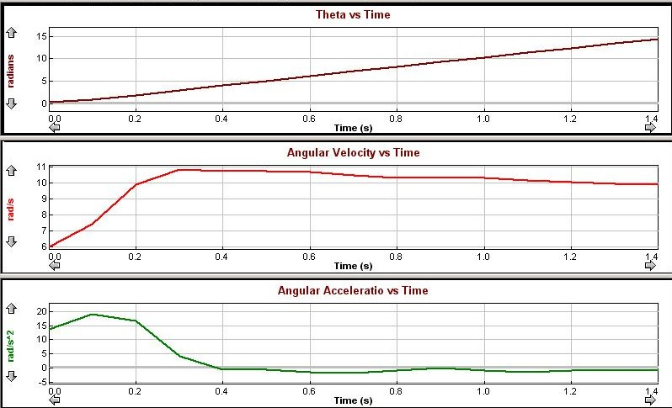
The graphs above fulfill the requirement of i), as it has a relatively constant acceleration after .4 s have elapsed. We can confirm this because the angular acceleration after .4 s is 0, and because acceleration is the derivative of velocity, we know that velocity must be constant in this case.

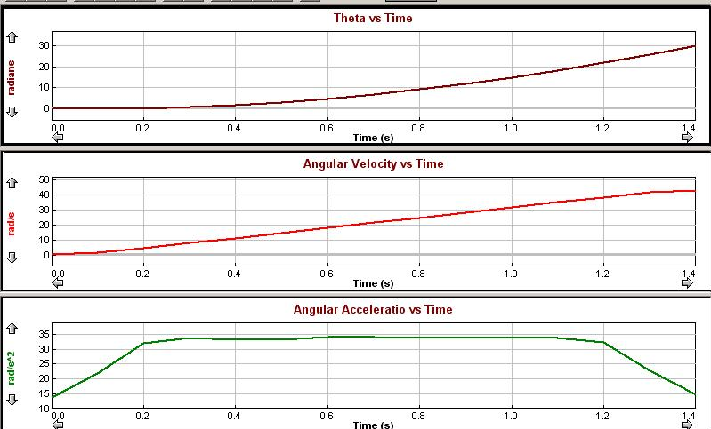
The graphs above fulfill the requirements of ii), as the velocity is increasing, and the angular acceleration is constant. The sharp incline at the beginning of the acceleration graph is due to a delay after collection of data had started and when the mass was released. The sharp incline at the end of the acceleration graph is due to a delay after the mass had stopped and collection of data had ended.
We can confirm that velocity is constant by observing that velocity is linear, and the derivative of a linear graph is a constant, in this case acceleration.

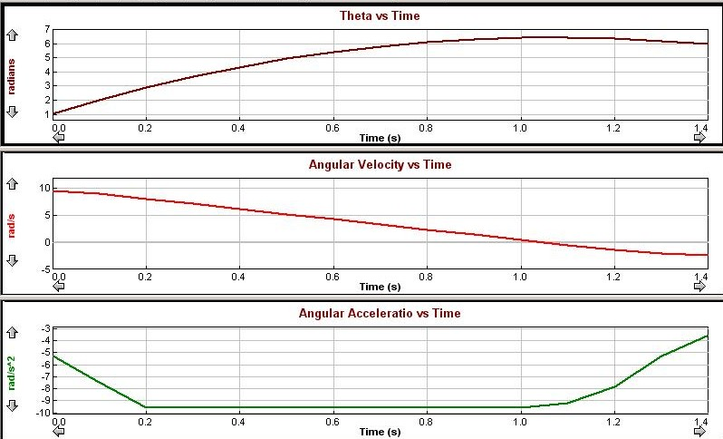
The graphs above fulfill the requirements of iii), as the acceleration is constant, and the angular velocity is decreasing. This only holds true, however, until the mass reaches the top of its motion. The point where the mass has reached it's peak is when the velocity graph crosses the x-axis, in other words when the disk is stopped. Also, we see, that the disk begins rotating in the opposite direction after the turning point in both the Theta and Velocity graphs.
For the next part of the experiment we used the same setup as i). We then measured both the vertical distance that the weights traveled and the rotational distance that the disk traveled. The data is shown in the chart below.

From this data, we can determine that. Then, using calculus, we can find out thatand.
For the next part of the experiment, our TA showed us a graph and had us determine what motion would reproduce the graph. We found that the graph was an extension of iii). Extending the sample time, we produced the following graph.
Until the turnaround point, the disk is spinning clockwise, as shown by both a negative velocity and theta. In this case, the acceleration is in a clockwise direction, as shown by the positive acceleration. After the turnaround point, the disk begins spinning counter-clockwise, representative of the positive velocity and the direction change of theta.

